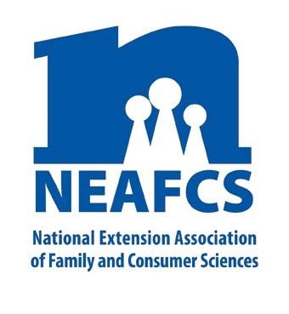
IMPACT 2014

Through Extension programs across the nation, Family and Consumer Science Extension Educators provide a multitude of educational opportunities to meet the needs of diverse audiences.

Food and Nutrition

Extension Food and Nutrition programming enables Americans of all ages to make healthier food choices that are also more economical. Extension educators use research-based information to create, teach and evaluate hands-on learning situations during which consumers gain not only content but confidence!

Expanded Food & Nutrition Education Program (EFNEP) and Supplemental Nutrition Assistance Program – Education (SNAP-Ed)

Utah’s EFNEP educators taught 834 adults, 15,140 youth and 3,367 family members in 2013. Eighty-nine percent of adult participants recorded having improved nutrition and food resource management practices. A five-state FCS Nutrition & Food Science Conference was co-sponsored with the Utah State Office of Education. One hundred sixty five FCS teachers, dieticians, and professionals in related fields were in attendance to receive the latest nutrition and food science updates.

SNAP-Ed educators made 467,174 education contacts with Oregon youth in schools during classes and after-school programs and during summer programs with camps and summer food service programs. Youth experienced nutrition education with fun interactive games and activities.

NEAFCS National Office | 20423 State Road 7, Suite F6-491 | Boca Raton, FL 33498
(561) 477-8100 | FAX (561) 910-0896 | www.neafcs.org
Six hundred sixty-one adult participants took part in EFNEP and SNAP-Ed classes in South Dakota. The majority of participants reported improvement in behaviors related to healthy eating (61%), budgeting and food resource management (83%), and food safety

(52%). These improved behaviors will help participants eat healthier and stretch their food dollars. The majority
of participants reported improvement in behaviors related to diet quality, budgeting and food resource management, food safety, and physical activity.

“When my food stamps were cut I didn't know how to feed my family healthy meals including fresh fruits and vegetables. With food resource management skills, I now choose fresh, frozen or canned and make menus from the grocery flyers.” -- Orange County Eat Smart NY participant
Mississippi’s EFNEP Making Healthy Choices with Pals has generated very positive responses from attendees, who noted that they learned how to use food thermometers, about food safety, the importance of nutrients found in certain foods, and how to read food labels.

Working Across the Age Spectrum – From Preschoolers to Senior Citizens

In Arizona FCS staff provided nutrition and physical activity programs across the state. In Cochise County, parents and caregivers of children age birth to five reported that 22% will use more 'family style' dining approaches; 15% will limit sugar intake; and 15% will pay attention to portion sizes. When teachers asked their
preschool students to draw what they learned, 35% drew healthy foods and 64% drew physical activity.

The Oklahoma Farm to You exhibit was experienced by 14,375 students at 50 schools in 29 counties. This brings the five year total to over 37,000 youth in 140 schools. The exhibit, when combined with the classroom-based nutrition program, enhanced nutrition behavior change
for upper-elementary grade students beyond that achieved with only the classroom-based program.

A program on emotional eating helped 135 Kansas high school teens, college students and grandmothers to understand the difference between hunger and emotional eating. A workforce of 25 Master Food Volunteers offer a variety of programs from Cooking 101, Farmer’s Market presentations, pen a regular column in a metro newspaper, and offer a series of health-related workshops in the community.

Basic food and nutrition is a programming area that is consistently offered by FCS educators in West Virginia to both adults and youth. Community classes are offered at churches, community centers, 4-H residential camps, and health clinics, just to name a few. Topics vary by county but some examples include cooking with herbs, kids in the kitchen, and how to read food labels.

New York FCS programs provided a series of interactive lessons designed to increase knowledge and skills. Participants improve knowledge of nutrition practices, food selection, food safety, food resource management, and physical activity.

Michigan State Extension positively impacted 42,913 adults to improve their healthy eating practices: 45% increased fruit consumption; 51% increased vegetable
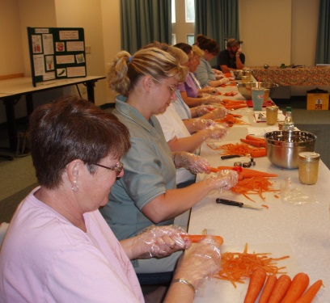

consumption; 38% increased whole grain consumption; 34% are more physically active; and 64% improved their
food resource management practices. Michigan Fresh, a state-wide campaign, focused on increasing awareness of agriculture, promoting fresh produce, and informing people how to grow their own produce.

In California, Alameda County Get Fresh Stay Healthy (a friendly interactive program targeting 500 low-income senior housing residents that addressed access, cultural, language, and literacy sensitivity) had a graduation rate of 95% and is being considered for a statewide pilot. The rapid increase in the number of older Californians at greater risk for foodborne illness and the need for nutrition education to promote healthy aging led to a 10 county assessment of 696 seniors, caregivers, and food handlers.

Training Volunteers and Professionals

Twenty-four individuals graduated from the Master Food Educator training, a 35-hour course in nutrition, physical activity and food safety, and now assist Delaware FCS staff in delivering nutrition programs in the state. Three community Family Fun Nights resulted in 119 individuals learning how to make safe and healthy brown bag lunches for themselves and their children.

A Maine FCS volunteer program was piloted in one county to help bridge the gap between having access to fresh produce at the food pantry, and knowing what to do with that produce. Volunteers demonstrated preparation and storage options for pantry users.
Cooking with Whole Grains is geared at Minnesota child care providers. The training helps them learn how to identify and cook with whole grains, and then introduce whole grains to children through experiential learning.

This report was compiled by Brenda Langerud, North Dakota State University Extension Service, Public Affairs Advocacy Subcommittee member, and Theresa Mayhew, Cornell Cooperative Extension, Vice President – Public Affairs. For more information, email tcm5@cornell.edu.
.

